**Process Ordering**

* **Register**

Input:

Username

Gender

Date of Birth

Telephone

Email

Password

Click **Register**

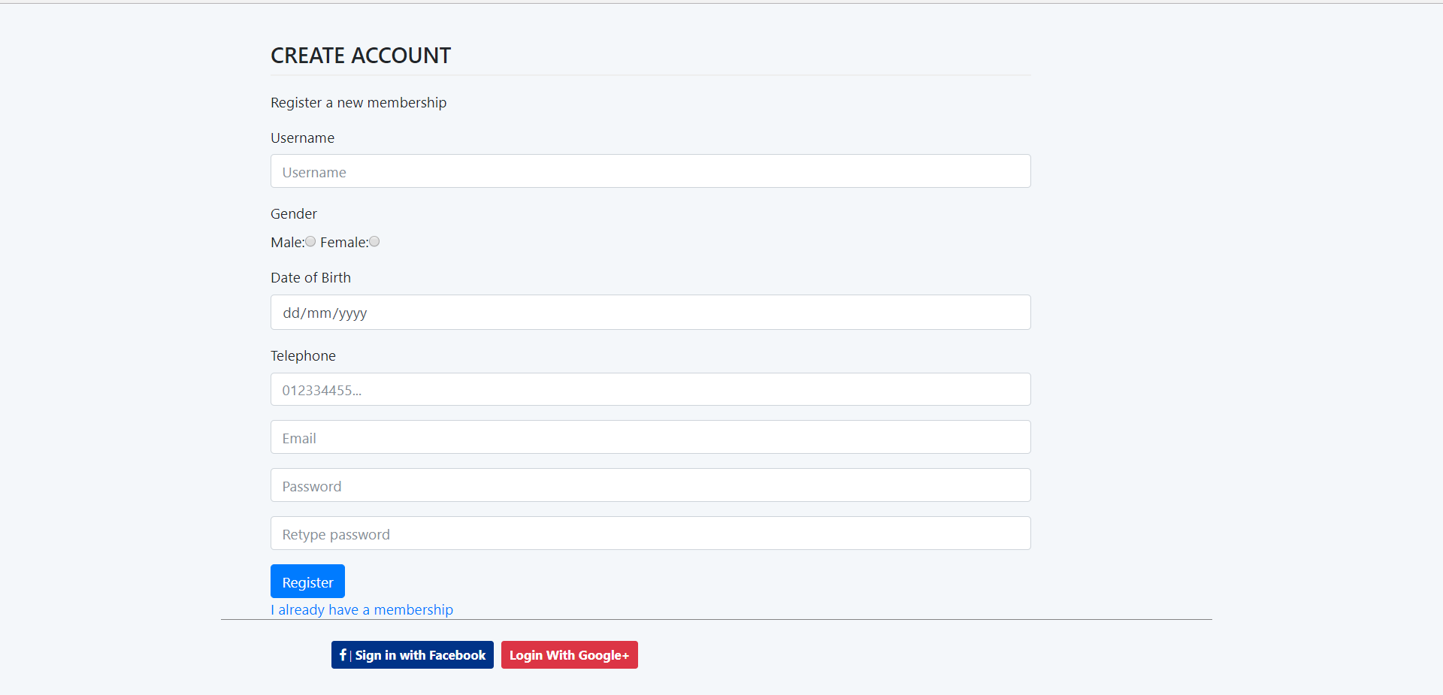

* **Log In**

Input:

Email

Password

Click **Sign In**

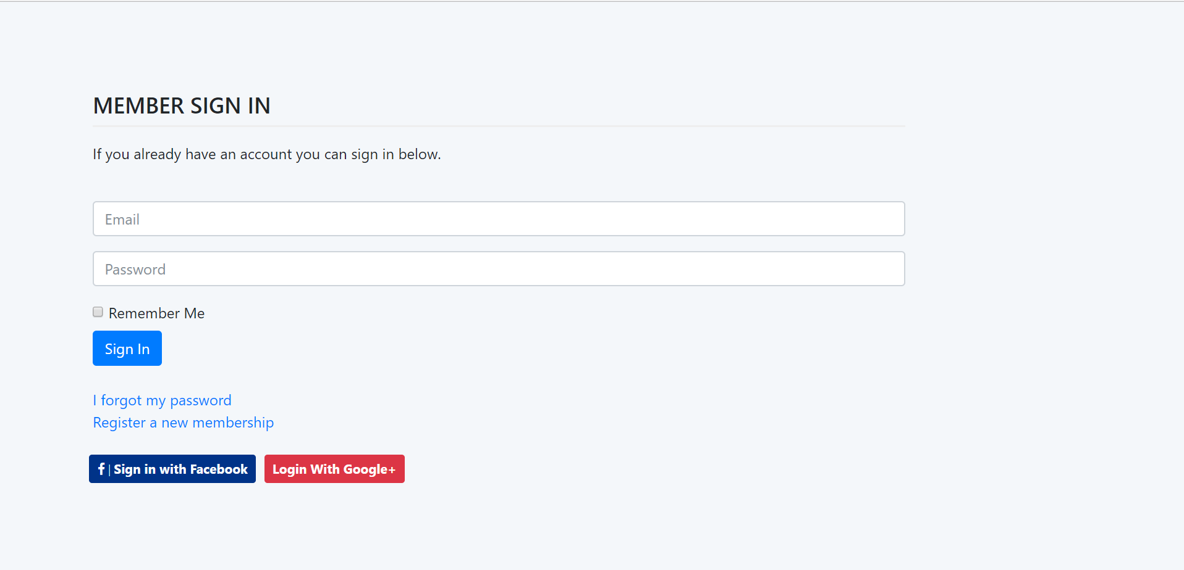

* **View Product Detail**

**Search Product**

Click on **View Detail** to view Product Description

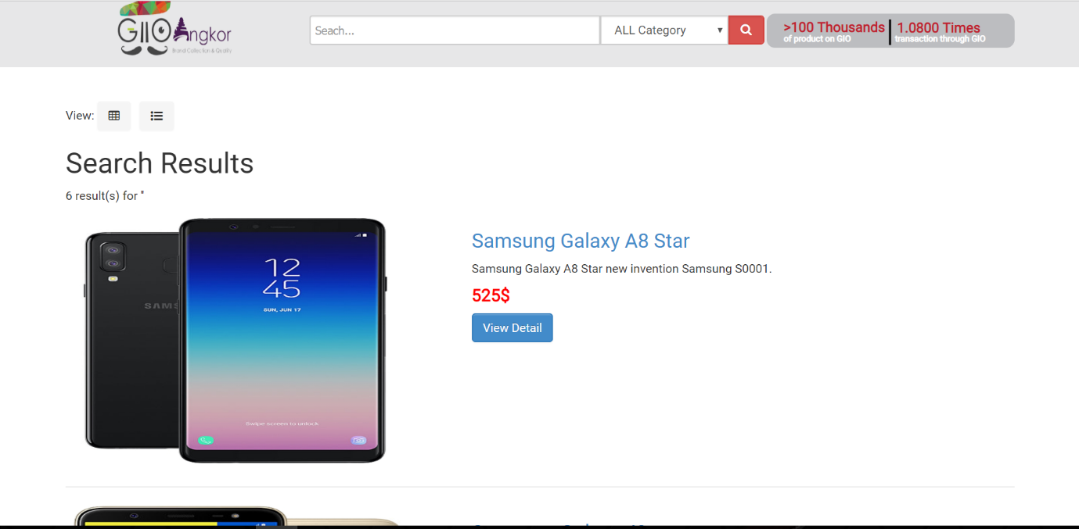

* **Product Detail**

Click **ADD TO CARD** to order product

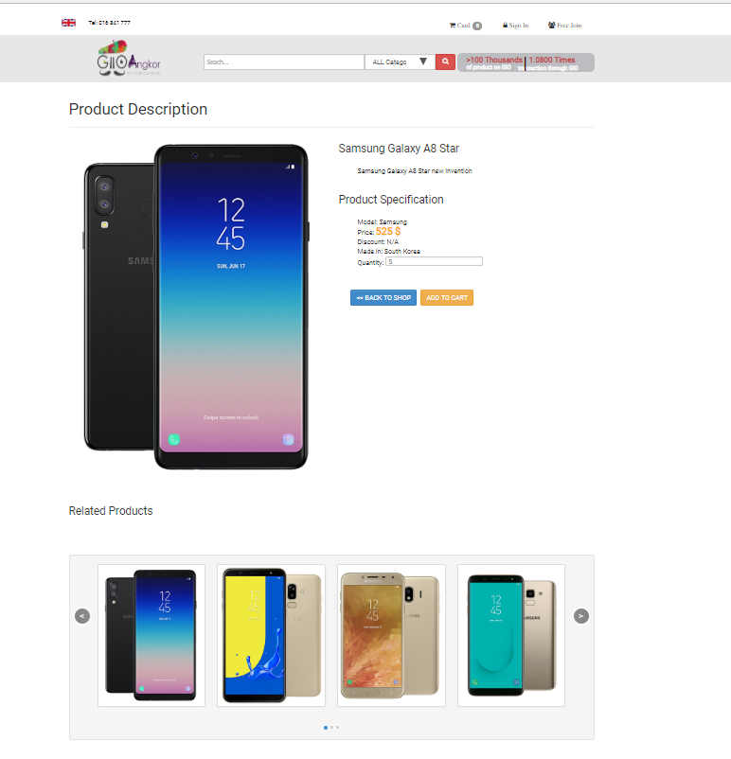

* **Add to card**

Click **Checkout** to input Order informaiton

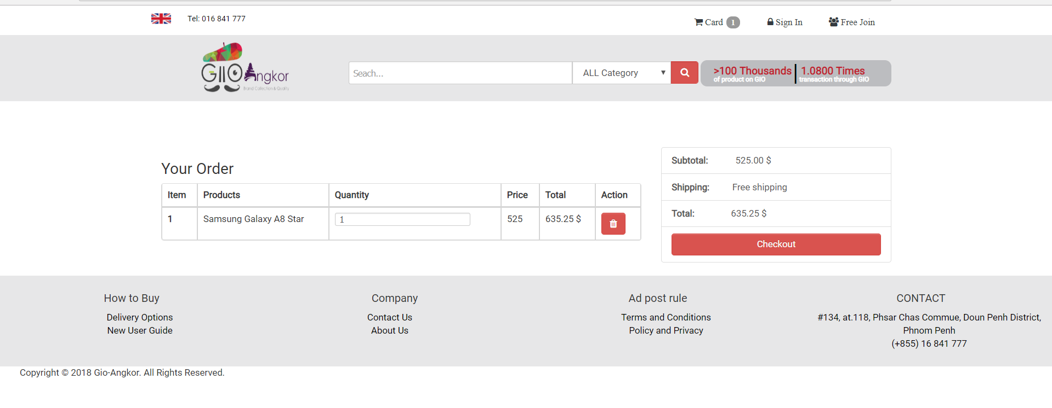

* **Checkout**

Input:

First Name

Last Name

Phone

Email

Click **Next**

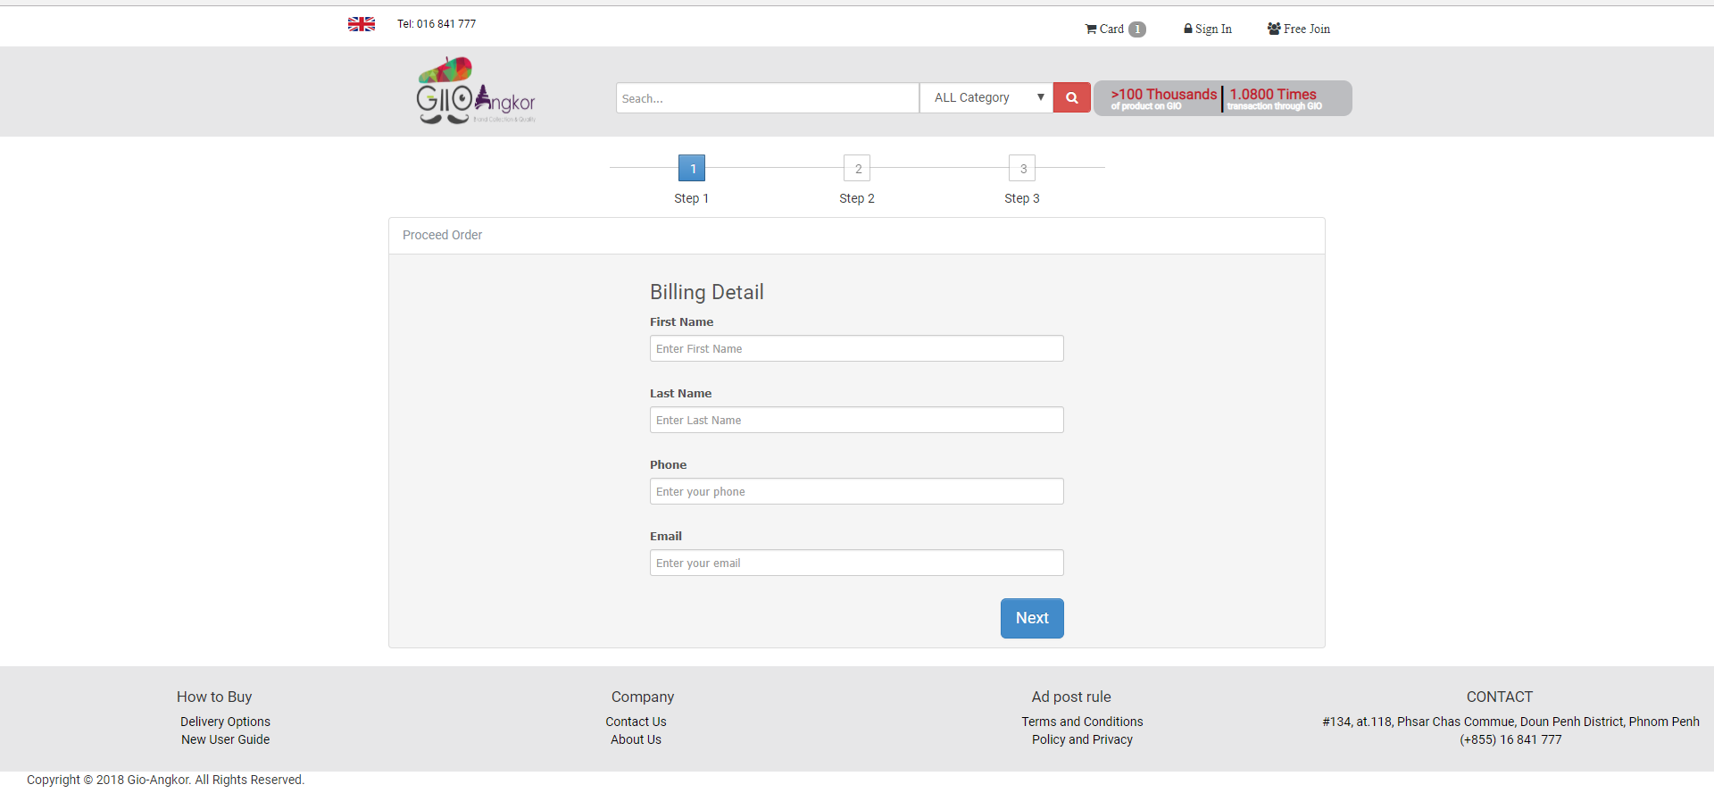

* **Process Order** 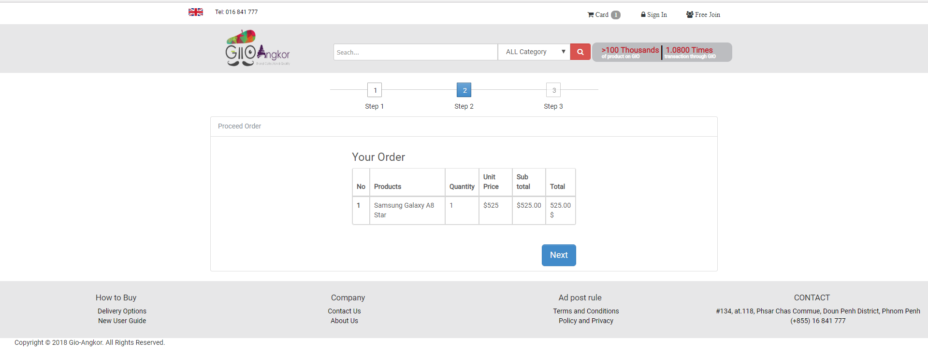
* **Payment**

Input:

Payment Type

Payment Code

Click **Place Order** to order Successful

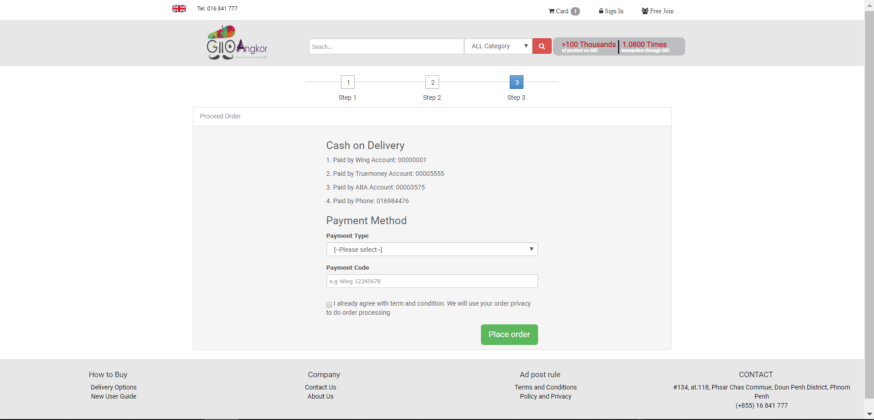

* **Order Successful**

